**AWS:**

**S3 Batch Operations**

Step 1: Go to aws management console and and navigate to s3

Step 2: create a s3 bucket with default settings or the settings that you require.here we kept all default.

Step 3: Now upload some objects in that bucket .for example here we upload 4 files two jpeg file and two html files namely : beach.jpg,coffee.jpg,index.html,error.html. Not compulsory to upload the same files or exact 4 ,you have to upload minimum 2 and maximum is up to you.

Step 4: now create a csv file (or excel file) having the following format:

**Bucket name ,object name**

For example in our case ,it will be :

s3-batch-demo786,coffee.jpg

s3-batch-demo786,beach.jpg

s3-batch-demo786,index.html

s3-batch-demo786,error.html

Step 5 : after creating that csv file then upload this in the same bucket .

Step 6: if you initially go through the tags of every object then there will be no tag.now we are going to add tags to every object inside the bucket.

Step 7: So for tags ,click on ‘ batch operations' present on the left side of the s3 dashboard and then click on “create job”.

Step 8: to create a job,

* select the region(where your bucket is placed)
* Then select the maifest format.as our file is in CSV format so we choose “CSV” but if you have another manifest type and choose the suitable one .
* After specifying the manifest format,now for manifest object : browse the same csv file that we upload in the bucket.then click on “next”.

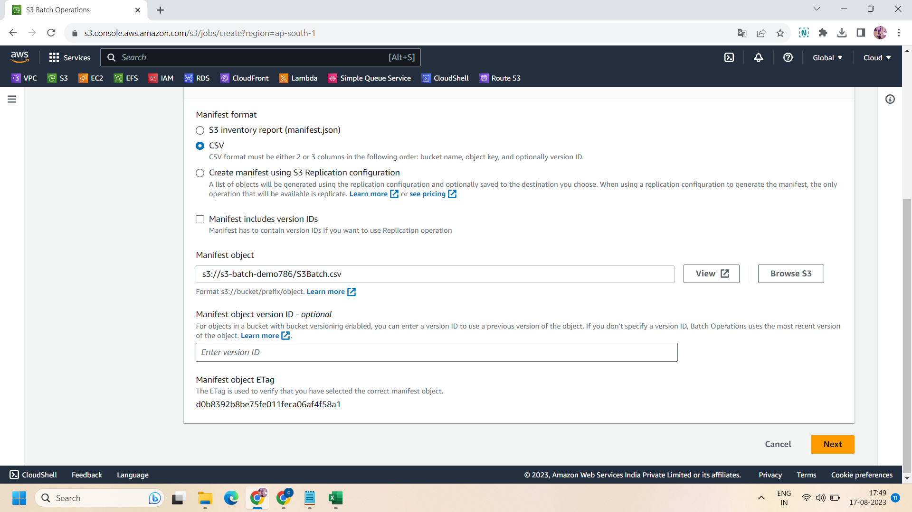

* Now in operation type ,we again have multiple options ,but we choose “replace all object tags” ,because we want to add tags.

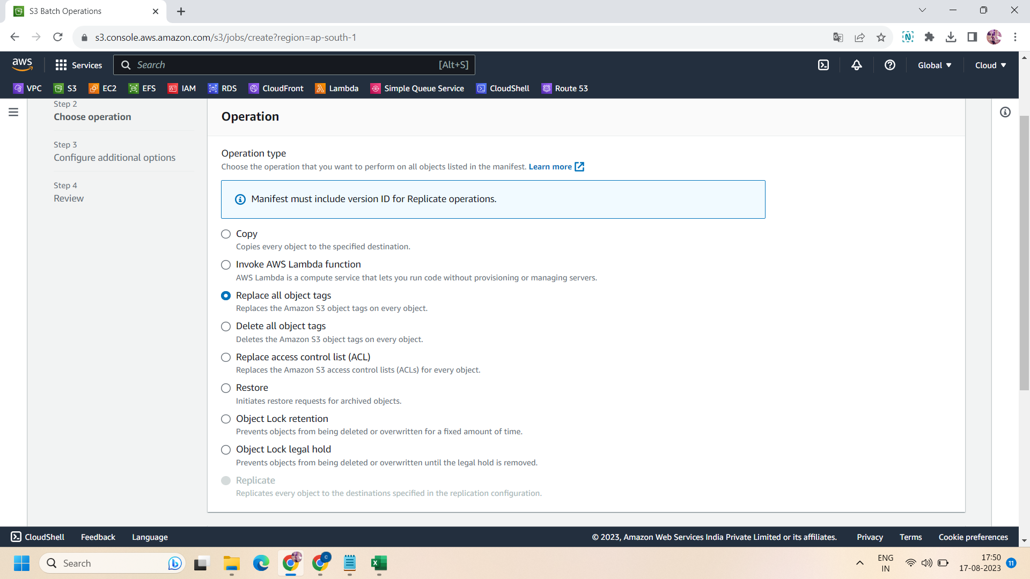

* Then add the key and values that you want to add .here we add batch as key and AWS as value.then click on “next”

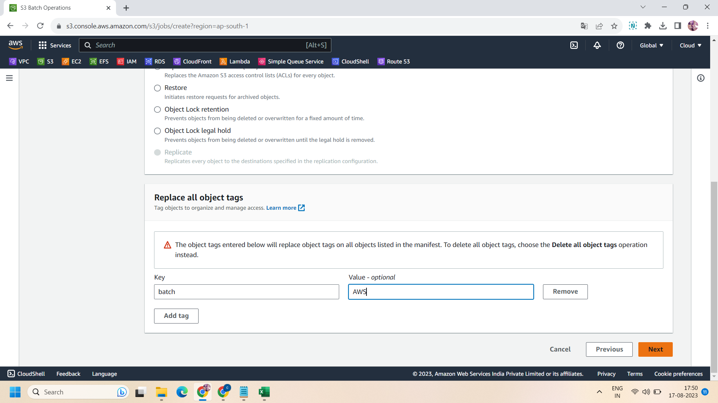

* Then additional options having description and priority ,we kept it by default .

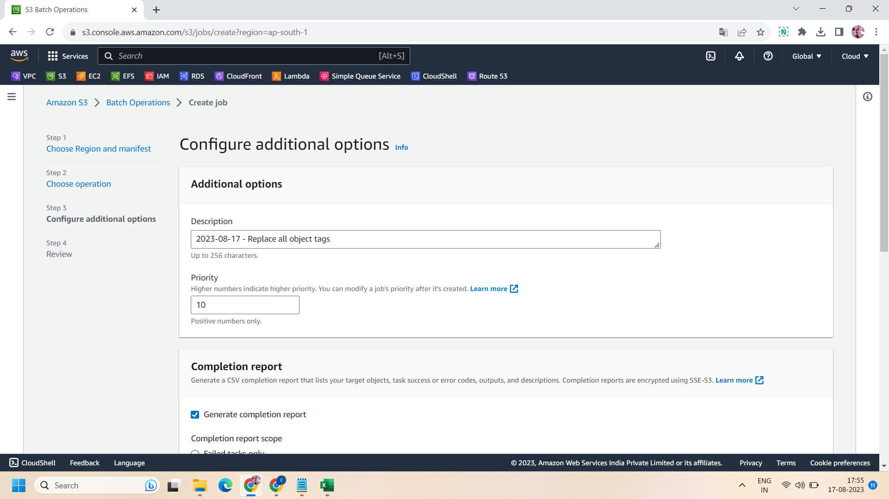

* Then completion report : we select “generate completion report” and “all tasks” then browse the path of your bucket and then add “ /batch-results” .

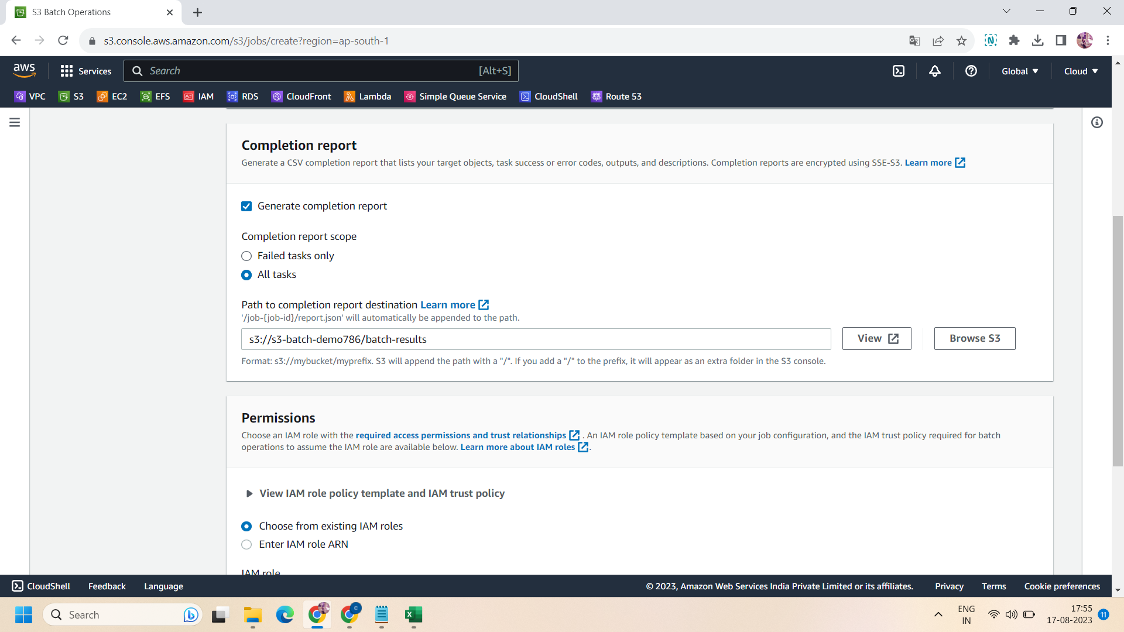

* Then after for permissions ,create new role having “Amazon S3 full access”.select the same in IAM permissions .then click on “next”

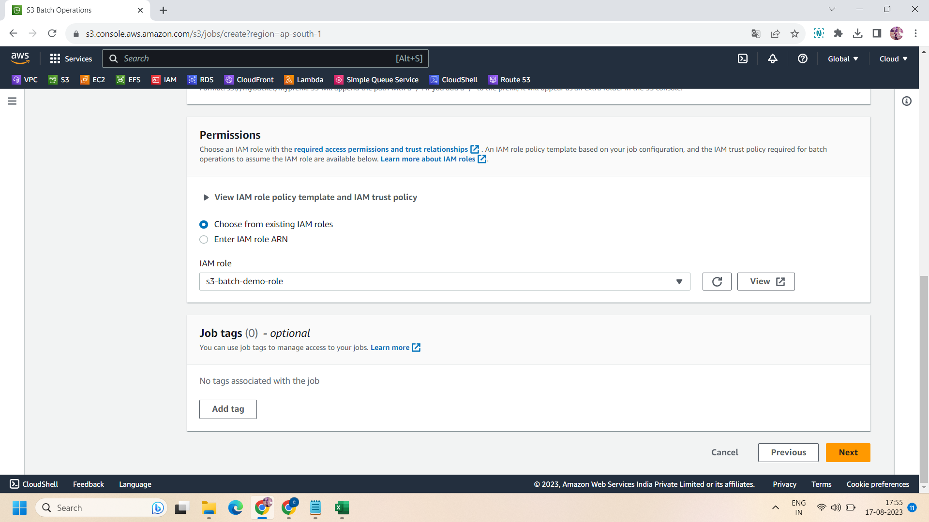

.

Step 9: Now ,your job will create,it will take a while then click on your batch job and click on “run job” at top right corner.and then scroll down and click on “run job”

Step 10: Now the job will start to run and the status of the job will change to “completed” .

Step 11: Now after all this ,if you go to your bucket and check the tags of every object,you will get the same key-value pair that we add at the time of job creation.

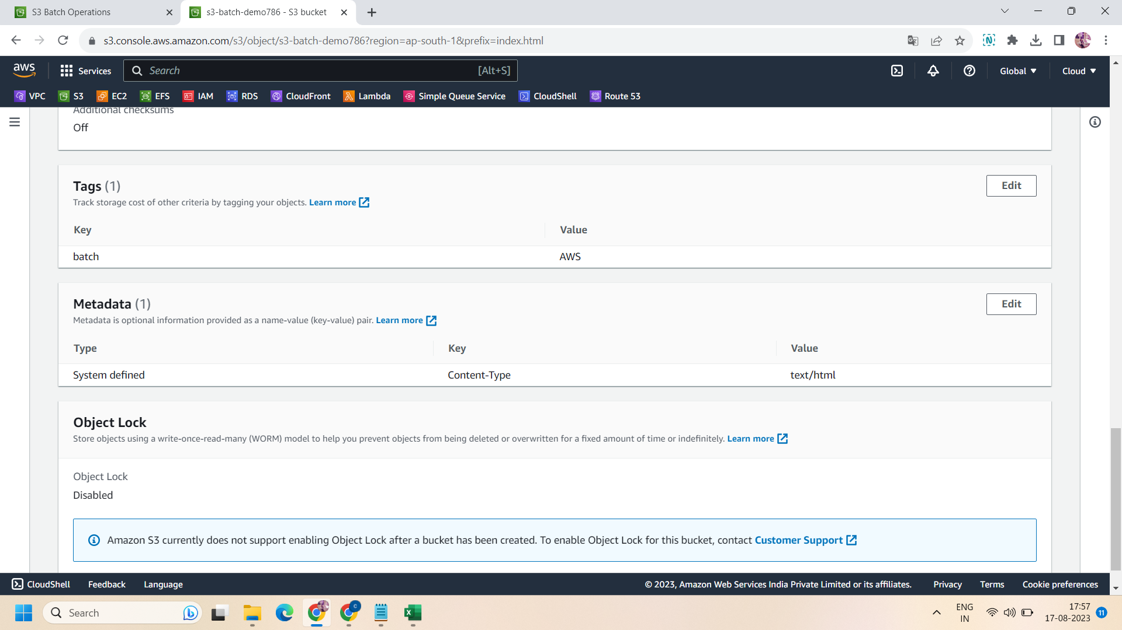

Step 12: for successfully done,make your csv file consist of every entry of each object in the bucket.

done!!

|  |  |
| --- | --- |
|  |  |
|  |  |
|  |  |
|  |  |